**India needs to enhance its global export share in hand tool sector**

The All India Association of Industries (AIAI) has been representing the interests of trade, industry and employment since 1956. We are pleased to make following suggestions on the above subject.

Hand tool manufacturing is a critical sector as it supplies tools such as wrenches, pliers, screw drivers, hammers, cable cutters, that have wide application in construction, automotive, electronics, shipbuilding, aerospace and other industries. Hand tools are also used in labour intensive manufacturing units such as watch making, gems and jewellery, wooden furniture, metal fabrication, to name a few.

As India enhances its manufacturing capability under the Aatma Nirbhar program, demand for mechanical hand tools is expected to grow. There are many small and medium enterprises manufacturing a wide variety of products such as spanners, hammers, plumbing tools, wrenches, measuring tools, masonry and carpentry tools, tools for gardening, pliers etc. MAGADH Hand Tools, Sterling Manufacturing, Deeps Tools, Alok Tools, Eastman Cast and Forge Ltd. are some of the prominent manufacturers and exporters of these tools in India.

Jalandhar and Ludhiana in Punjab and Nagaur in Rajasthan host prominent hand tool clusters in India. The Central Institute of Hand Tools (CIHT) in Jalandhar is the leading organization that supports the development of hand tool industry in the country. The institute supports small and medium enterprises in design of tools and also provides common facilities for forging, dies, tools, jigs and fixtures.

**India Net Exporter**

India not only caters to the domestic demand for hand tools, but it is also an exporter of some of these products. India exports hand operated spanners, glaziers (used in diamond processing industry), vices, clamps, pliers, sledge hammers, grease guns etc.

India is a net exporter of hand tools as it exports USD 270 million worth of these products, while importing USD 82 million, thus having a trade surplus of USD 188 million. However, exports have declined sharply from USD 336 million in 2011-12 to USD 270 million in 2019-20. The following table shows India’s export, import and trade balance in various hand tools during 2011-12 and 2019-20.

Imports of hand tool has grown from USD 72 million to USD 80 million since 2011-12 as many local user industries started importing cutting edge tools from China, Taiwan, France, Germany, Japan and other global suppliers.



Major reasons for decline in exports are poor demand in European countries, which are the major markets for Indian hand tools, competition from Chinese exporters, lack of technology upgradation by domestic manufacturers etc. Rising demand for power tools has also reduced demand for hand operated tools. User industries are opting for battery-charged automated tools instead of using brick and mortar hand tools.

As the following table shows, world exports of hand tool stands at USD 13.3 billion, of which India’s share is 1.5%-4.6%, depending on the type of tools. India has a share of 4.6% in world export of hand operated spanners & wrenches; on the other hand, its share is 1.5% in export of glaziers’ diamond, blow lamps, vices etc. Major exporters of hand tools are China, Taiwan, Germany, USA, France and UK. India is the fifth largest exporter of hand operated spanners & wrenches. India does not figure in the top five exporters list in other segments of hand tools. Major importers of hand tools are USA, Germany, Canada, France, UK and Netherlands.

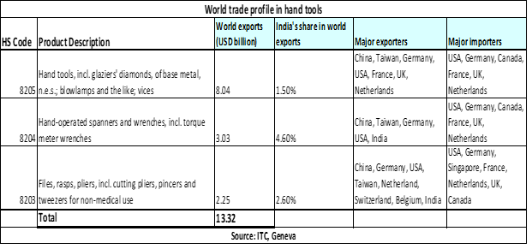

**Opportunities and challenges**

India’s export of hand tools is less than USD 300 million, while the global export is USD 13.32 billion, which signifies huge untapped export potential for India. Currently, USA, UK, Germany, Brazil, UAE and Nigeria are major export destinations of hand tools. India should diversify its export market to Asia, Africa and Latin America.

Also, government and industry association should work together for technology upgradation and modernization of manufacturing units of small and medium enterprises. The local hand tool manufacturers have sought government assistance in terms of waiver of duty for import of machineries to modernize plants, access to capital at reasonable interest cost and financial support for purchase of land and cutting edge technologies. A coordinated action between industry associations and government will not only promote exports of hand tool, but also help control the growing imports.